**STOCK PORTFOLIO MANAGEMENT SYSTEM**

High Level Design & Low Level Design

**Document Control :**

|  |  |  |  |  |  |  |  |  |
| --- | --- | --- | --- | --- | --- | --- | --- | --- |
| **Stock Portfolio Management System** | | | | | | | | |
| Guided by-  **Mr. Sankar** |  |  | |  |  |  |  |  |
| **Date** | **Version** | **Author** | **Brief Description of Changes** | | | | **Approver Signature** | |
| December 07 2022 | 1.0 | Sruthi Kavishetti  Devi Priya Putta  Goli Varsha  Guna Swetha Madaka  Jannu Deepthi |  | | | |  | |

# 

1. **INTRODUCTION**

The stock portfolio management system is the art and science of selecting

and overseeing a group of investments that meet the long-term financial objectives and risk tolerance of a client, a company, or an institution.

Some individuals do their own investment portfolio management. That requires a basic understanding of the key elements of portfolio building      and maintenance that make  for success, including  asset  allocation, diversification, and rebalancing.

Investment portfolio management involves building and overseeing a    selection of  assets  such as stocks, bonds, and cash that meet the    long-term financial goals and risk tolerance of an investor.

**1.1 BACKGROUND**

Technical analysis is an approach to predicting future price movements based

on identifying patterns in prices, volume and other market statistics. Technical analysis usually proceeds by recording market activity in graphical form and then deducing the probable future trend from the pictured history. The premise is that prices exhibit various geometric regularities, which, once identified, inform the trader what is likely to happen next. This in turn allows the trader to run a profitable trading strategy. Technical analysis is prevalent in financial markets and is readily accessible in practitioner texts such as pring (2002), in the form of tools provided by online brokers such as Barclays Stockbrokers (www.stockbrokers.barclays.co.uk) as well as in the form of commentary in the financial and investment press.

**1.2 PURPOSE**

Technical stock screeners allow you to filter stocks according to many of the same price-dependent technical indicators that you would use on a stock chart. So, technical screeners can be extremely valuable for traders who normally trade momentum, reversal, or other short- and medium-term strategies.

**1.3 HOW STOCK PORTFOLIO WORK**

Stock screeners allow investors to weed through the extensive field of potential financial investments using their own criteria. Users begin the process by selecting certain investing parameters, based on their personal requirements.

For example, a fundamental investor may be most interested in market capitalization, analyst recommendations, earning per share (EPS), operating cash flow, multi-year return on investment (ROI), dividend yield, and the like. A technical trader would be more interested in moving average levels/crossovers, relative strength index (RSI) levels to indicate momentum, average directional index (ADX) readings to indicate strength, and chart patterns, among others.

**1.4 KEY PROJECT OBJECTIVES**

* To supply capital - To achieve this task, ownership in a private corporation is sold to the public in the form of shares of stock. Funds received from the sale of stock contribute to the firm’s capital formation.
* Toinspiresavings - This inspires people to save their income by making a profit. Continuous purchase and sale of securities on a stock exchange lead to the evaluation of their prices.
* Todevelop economy - It helps economic development by supplying the capital to the industries.
* To protect fraudulently**-**It is also to ensure that no fraudulence occurs in a transaction.
* To do long-term financing - Commercial banks generally disburse the short-term loan. So, supplying long-term finance is an objective of the stock exchange.

**1.5 FUNCTIONAL OVERVIEW**

**1.5.1 HEADER FILES**

* stdio.h
* stdlib.h
* string.h

**2.DESIGN OVERVIEW**

|  |  |
| --- | --- |
| Name of the Module | Top level menu and user interaction.  Single OS authenticated user. |
| Handled by | Devi Priya Putta, Deepthi |
| Description |  |

|  |  |
| --- | --- |
| Name of the Module | Stock master menu for addition, deletion and modification of stock. Stock will not be deleted if a position in a specific stock is existing or there is trade in stock during current FY. |
| Handled by | Varsha Goli, Shruthi, Swetha |
| Description | Developed code on update and delete operations and implemented . |

|  |  |
| --- | --- |
| Name of the Module | Stock trade/contract note addition , deletion and modification. Trade inputs will consists of stock code, Quantity, B or S, Trade Price and Other expenses. |
| Handled by | Deepthi , Shruthi , Devi Priya |
| Description | Researched and developed all the conditions and functions on Buy and sell. |

|  |  |
| --- | --- |
| Name of the Module | Application will maintain daily price movements by a stock closure price provided in a file at a specific location. P&L and MTM calculator and report displayed on selecting a menu |
| Handled by | Swetha, Varsha, Shruthi |
| Description | Developed code in creating sales record and designed dataflow diagrams and flow charts |

|  |  |
| --- | --- |
| Name of the Module | Tax estimate report based on Tax Rules of Current FY. They will be hard coded. Reports |
| Handled by | Deepthi, Devipriya |
| Description | Developed code on update the overall tax reports. |

**4. DETAILED SYSTEM DESIGN**

**4.1 HLD&LLD**

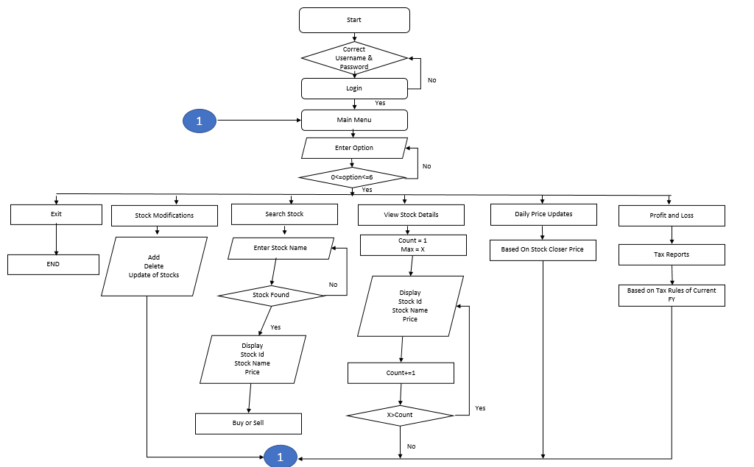

**HLD-High level diagram**

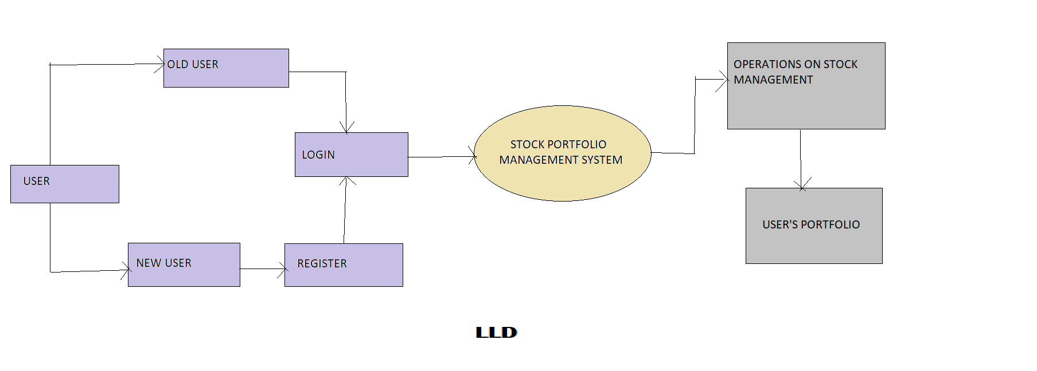

**4.2 DATA FLOW DIAGRAM**

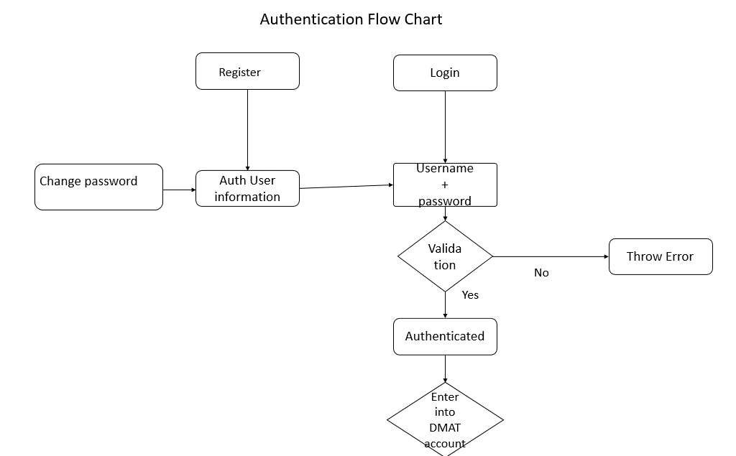

**4.2 DATA OVERVIEW**

​

**5.ENVIRONMENT DESCRIPTION**

**5.1 Time Zone Support:** IST- Kolkata

**5.2 Language Support:** English

**5.3 User Desktop Requirements**

* + 64-bit processor, 1.50 GHz or faster
  + At least 10 GB free hard drive space
  + At least 1 GB RAM Server

**5.3.1** **Integration Requirements**

* + - Language: C
    - Tools: Valgrind
    - Complier: gcc
    - Linux Environment

**5.3.2 Network:** End to End

**5.3.3 Configuration:**

Operating System: Linux environment

**6. REFERENCES**

The references are:

<https://corporatefinanceinstitute.com/resources/wealth-management/stock-screener/>

<https://www.investopedia.com/terms/m/movingaverage.asp>

<https://www.nirmalbang.com/knowledge-center/use-moving-average-for-buying-stocks.html>

<https://www.nseindia.com/market-data/live-equity-market>

<https://www.researchgate.net/publication/251335107_Market_Timing_With_Moving_Averages>